**Lab3 Sample Output**

**Part1 : output examples**

**Original Output (10 and 2 test positive numbers)**

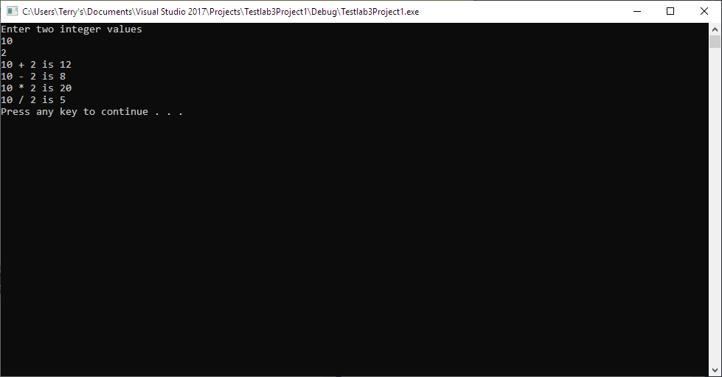

**Original Output (-8 and -2 test negative numbers)**

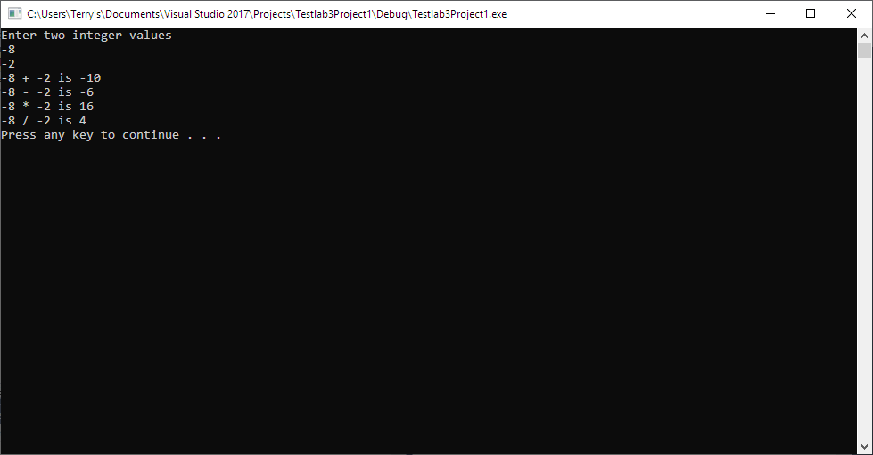

**Original Output (10 and 0 test) You get an error ; Test for 0**

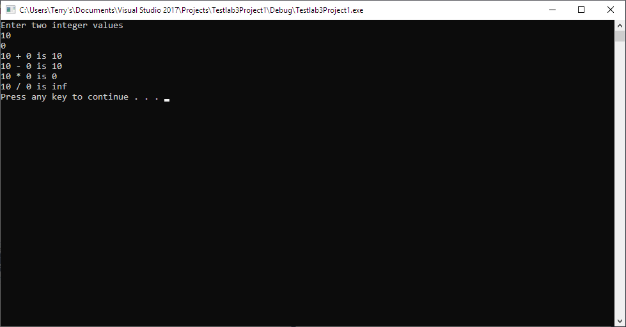

Original Output (5 and 3 testing **the casting and it works**)

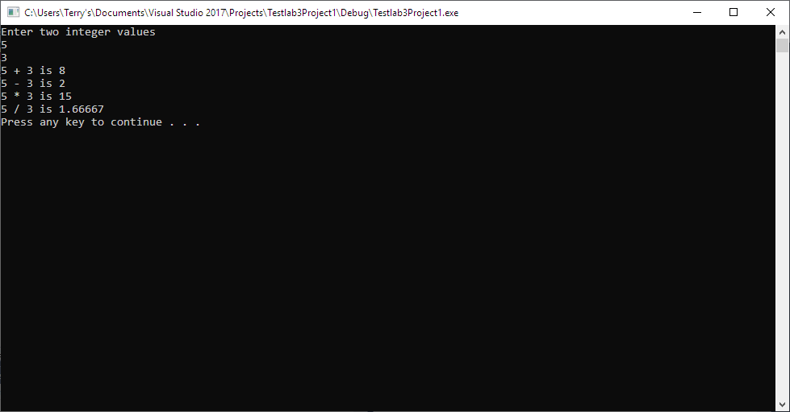

**Modified added Modulus Output (5 and 3)**

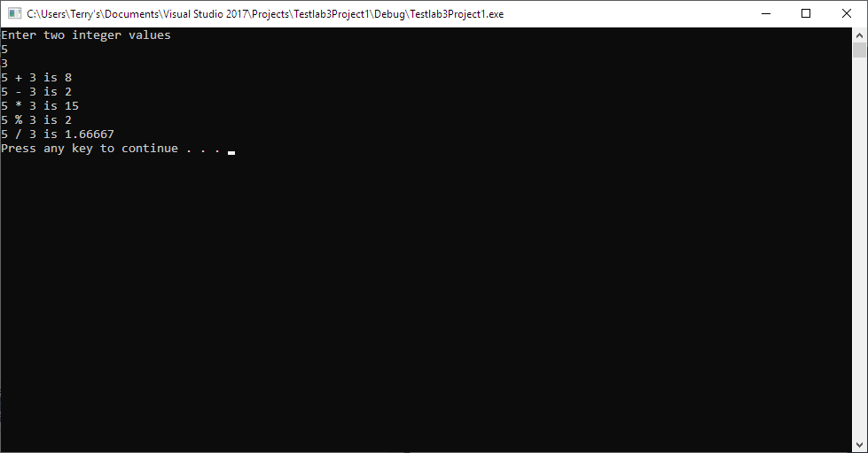

**When you do (5. Of part 1) make sure you test for dividing by 0**

